**What is Path Testing?**

Path testing is a structural testing method that involves using the source code of a program in order to find every possible executable path. It helps to determine all faults lying within a piece of code. This method is designed to execute all or selected path through a computer program.

Any software program includes, multiple entry and exit points. Testing each of these points is a challenging as well as time-consuming. In order to reduce the redundant tests and to achieve maximum test coverage, basis path testing is used.

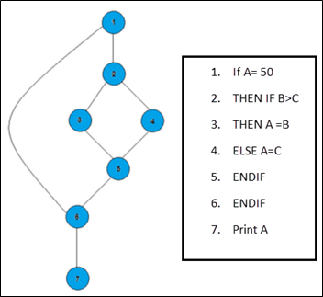

n the above example, we can see there are few conditional statements that is executed depending on what condition it suffice. Here there are 3 paths or condition that need to be tested to get the output,

* **Path 1**: 1,2,3,5,6, 7
* **Path 2**: 1,2,4,5,6, 7
* **Path 3**: 1, 6, 7

## Steps for Basis Path testing

The basic steps involved in basis path testing include

* Draw a control graph (to determine different program paths)
* Calculate [Cyclomatic complexity](https://www.guru99.com/cyclomatic-complexity.html) (metrics to determine the number of independent paths)
* Find a basis set of paths
* Generate test cases to exercise each path

## Advantages of Basic Path Testing

* It helps to reduce the redundant tests
* It focuses attention on program logic
* It helps facilitates analytical versus arbitrary case design
* Test cases which exercise basis set will execute every statement in a program at least once

**Conclusion:**

Basis path testing helps to determine all faults lying within a piece of code.